FOR IMMEDIATE RELEASE Evan Summers
February 4, 2020 media@prosthodontics.org

Montefiore Medical Center Prosthodontist Named 2019 Educator of the Year by National Organization
Dr. Gary S. Rogoff recognized by the American College of Prosthodontists

CHICAGO – Gary S. Rogoff, DDS, MS, FACP, was honored with the 2019 Educator of the Year Award from the American College of Prosthodontists (ACP). This award recognizes exceptional skills as a dental educator and outstanding contributions to academic and professional dentistry. He received the award at the 49th Annual Session of the ACP held in Miami, Oct. 30-Nov. 2, 2019.

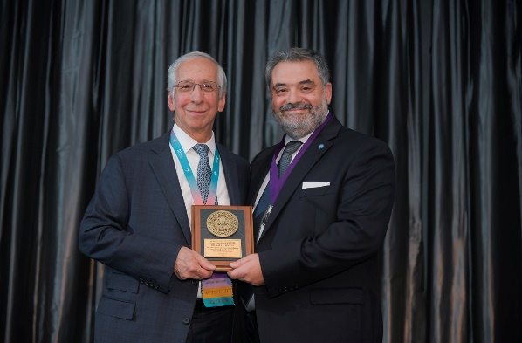
“The honor of being named ACP Educator of the Year means that my efforts to contribute to the specialty of prosthodontics have ‘made a difference’, and that I have contributed to the success of others by sharing my knowledge and experiences with the many outstanding students and faculty with whom I have been privileged to work,” said Dr. Rogoff.

“My mentor, Dr. Allen Brewer, always encouraged his students to embrace the philosophy of ‘paying it forward.’ Being recognized with this award is an inspiration to continue doing the same for my students.”

Dr. Rogoff is Chief of the Division of Prosthodontics and Director of the Prosthodontic Residency Program at Montefiore Medical Center, Bronx, New York. His teaching career began with an appointment to the faculty of The University of Rochester School of Medicine and Dentistry. His subsequent academic positions included appointments at Tufts Dental School, the Forsyth Institute, Harvard School of Dental Medicine, and the Boston V.A. In 2007, he returned to New York City to join the Department of Dentistry at Montefiore.

###

About Prosthodontists
A prosthodontist is a dental specialist who focuses on the restoration and replacement of missing teeth and other oral or facial issues. Prosthodontists specialize in helping patients with implants, dentures and veneers, all the way to full mouth and jaw reconstructions.

About the ACP
The American College of Prosthodontists (ACP) is the only ADA recognized organization for the specialty of prosthodontics. Founded in 1970, the ACP is dedicated to advancing the art and science of prosthodontics and promoting the specialty to the public and dental professionals. For more information, consumers can visit GoToAPro.org and dental professionals can visit Prosthodontics.org.

Photo Caption: Dr. Gary S. Rogoff (left) receives the Educator of the Year Award from ACP Immediate Past President
Dr. Nadim Z. Baba at the 49th Annual Session of the ACP held in Miami, Oct. 30-Nov. 2, 2019.

