Steps to a Successful Oral Health Screening Event
- Determine the goal for the event, anticipating the public need
- Create a timeline for the event
- Determine a date and location
- Delegate activities to team members
- Obtain consent to use public space if needed, and see if you need liability insurance
- All Screeners must be licensed in the state where the OCS is taking place
- Make sure there is a licensing agreement signed and on file in the Central Office for Section use of the ACP logo for all fliers and advertisements for the event.
- Determineif you want sponsors/partners for the event, perhaps stores, foundations, organizations, universities, suppliers in your area
- Create event flyers
- Create public service announcements, press release and calendar listing
- Identify local television, newspaper and radio contacts to send information to
- Create banners to identify event: registration, exam, etc.
- Identify and calibrate “screeners”
- Identify “wranglers” to assist directing the public or answer questions
- Identify media/communication experts who can assist you on site
- Be prepared to be interviewed by media if they attend
- Obtain appropriate and supportive patient informational brochures or pamphlets
- Obtain a clinical mobile van, tents, and chairs if needed
- Obtain expendable examination supplies from local dental supplier, such as:
- Head lamps‐battery operated
- 2 x 2 Gauze
- Disposable mouth mirrors
- Tongue blades
- Antiseptic lotion
- Nitrile Gloves (non‐latex) medium to large size
- Face Masks
- Facial Tissues
- Waste Receptacles
- Prepare patient agreement, examination and referral forms (attached)
- Create a list of health care providers/institutions that will accept referrals
- Create a means to publically recognize contributors with banners, poster‐boards, etc.
- Create buttons or stickers for individuals screened
- Have adequate chairs and/or refreshments for individuals waiting for screening
- Follow‐up with a letter of thanks for all of those involved

Oral Cancer Screening Consent Form

I consent to an evaluation of my head, face, neck, upper torso and oral cavity for unusual skin or mucosal changes that might be associated with a disease process. I understand that this evaluation is only a screening. I will be informed verbally if areas of concern are noted. I will then assume the responsibility to contact my physician or dentist for a complete evaluation, diagnosis and treatment as needed.

Name (Please print)
Signature
Date

Examination Form

APPEARANCE
Color
- Red Color
- White Color
- Red/White Color
- Normal overlying mucosa

Surface
- Cobblestone texture
- Ulceration
- Smooth

PALPATION
- Firm
- Soft
- Moveable
- Causes bleeding

DIMENSION
- Surface dimension
- Depth dimension

EXTRAORAL FINDINGS
- Neck mass
- Location of neck mass
- Size of neck mass

SIGNS AND SYMTOMS and HOW LONG HAS EACH BEEN PRESENT
- Sore throat
- Earache
- Painful swallowing in throat
- Pain at lesion site
- Occasional bleeding at the site
- Awareness of the lesion
- Any change in the lesion

HISTORY
- Smoking
- Alcohol
- Previous lesion in the area with a past diagnosis of _____________

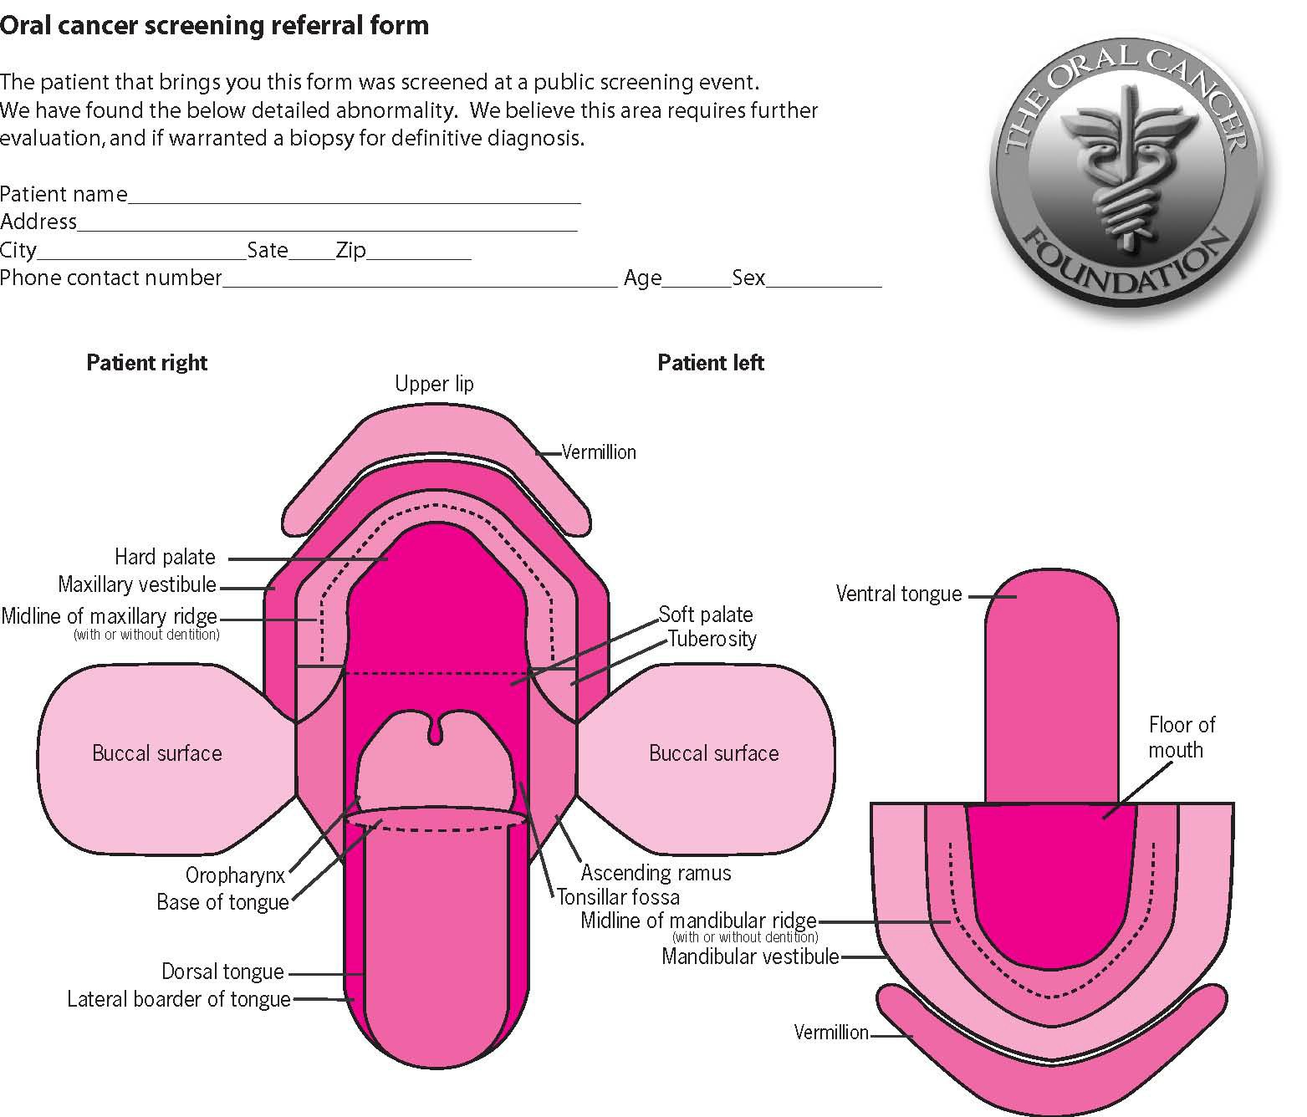

Description of suspect tissue/area:

Examiner: Printed Name:

Contact Information:

