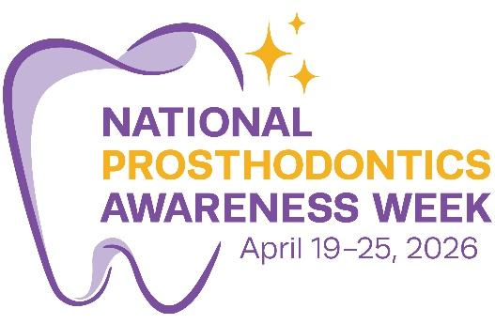

Below is the suggested text for the 2026 National Prosthodontics Awareness Week social media graphics. The name of the photo it accompanies is bolded. Please feel free to alter the text as you deem fit for your personal use.

(NPAW26-PhoneticSpelling.png) We are excited to be celebrating the 2026 National Prosthodontics Awareness Week. Prosthodontics is the dental specialty that combines art and science to restore teeth, function, and confidence. Follow along all week as we explore different areas of prosthodontics and the role we play in maintaining and promoting oral health. #NPAW2026 #Prosthodontics

(NPAW26-CosmeticDentistry.png) Cosmetic Dentistry: Prosthodontists are experts in advanced esthetic and reconstructive dentistry, with specialized training in smile design, facial harmony, and dental material science to create natural, long-lasting results. #NPAW2026 #Prosthodontics

(NPAW26-Digitalinnovation.png) Digital Innovation: Prosthodontists are leaders in advancing digital dentistry through the integration of CAD/CAM technology, 3D printing, jaw tracking, and emerging artificial intelligence tools to deliver highly precise, personalized care. #NPAW2026 #Prosthodontics

(NPAW26-FullMouthRehab.png) Full Mouth Rehabilitation: Beginning with the end in mind, prosthodontists understand the complex relationship between teeth, occlusion, muscles, and joints, ensuring restorations are not only beautiful but comfortable and functionally stable. #NPAW2026 #Prosthodontics

(NPAW26-Maxillofacial.png) Maxillofacial Prosthodontics: This advanced branch of prosthodontics requires one additional year of training and focuses on restoring patients who have experienced trauma, cancer, or congenital disorders, providing highly specialized care to rebuild both function and quality of life. #NPAW2026 #Prosthodontics

(NPAW26-FixedProsth.png) Fixed Prosthodontics: Prosthodontists are trained in all aspects of implant dentistry, including smile design, surgical implant placement, and fabricating prostheses that blend seamlessly leading to a beautiful, confident smile. #NPAW2026 #Prosthodontics

(NPAW26-RemovableProsth.png) Removable Prosthodontics: The branch of prosthodontics that deals with replacement of teeth and tissue with partial and complete dentures that can restore form, function, and esthetics. #NPAW2026 #Prosthodontics

(NPAW26-Conclusion-Smile.png) Prosthodontists are the architects of the smile and the entire functionality of your mouth: specialists who take the full picture into account to deliver esthetic, precision-engineered, and functional solutions tailored to each patient we care for. #NPAW2026 #Prosthodontics

