The Virginia Section of the American College of Prosthodontists would like to invite you to our upcoming webinar “The Latest Techniques and Concepts in Bone Grafting” presented by Dr. Daniel Hsu on November 18 2021 from 6:30-8:30 pm.
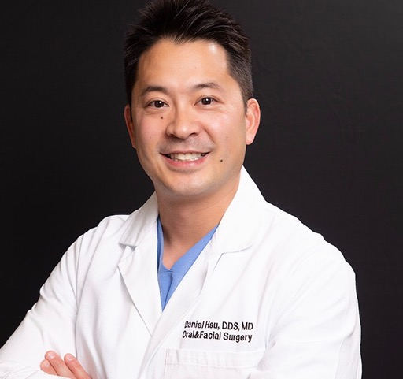
Dr. Hsu received his MD and DDS from Columbia University and is a Diplomate of the American Board of Oral and Maxillofacial Surgery and Fellow of the American Academy of Oral and Maxillofacial Surgeons. He is a former assistant clinical professor at Columbia University and has a private practice that focuses on implant dentistry.
Dr. Hsu will be focusing on the latest techniques and concepts in bone grafting to include the sausage GBR technique, bone graft limitations, peri-implant defects, and lip repositioning procedures for esthetics.
Educational Objectives
- Learn how to manage extraction socket defects
- Learn membrane placement and management
- Learn how to utilize growth factors in bone grafting - BMP-2 and PRF
- Learn how to utilize patient specific custom 3D titanium mesh
- Learn the principles of sinus lifting
- Learn how to utilize osseodensification in bone grafting
- Learn how to treatment plan hard and soft tissue defects
- Learn treatment of peri-implant defects utilizing bone graft
We hope you will join us for this educational virtual lecture in November!
Sincerely,
Charlson Choi
Pandora Wojnarwsky
Ursula Klostermyer
Natalie Powell

This Continuing Education will be free to current ACP-VA members. There will be a non-refundable $50 fee for non-members. There is no commerical support for this webinar and no confilicts of interest to disclose.
This continuing education activity has been planned and implemented in accordance with the standards of the ADA Continuing Education Recognition Program (ADA CERP) through joint efforts between The American College of Prosthodontists and Virginia Chapter of the American College of Prosthodontists and will be awarded 2.0 CE credits upon completion.
Participant Information

Name:

Address:

Please send checks made payable to the ACP-VA Section to

Ursula Klostermyer
7204 Glen Forest Drive #203
Richmond, VA 23226

This event qualifies for 2 hours of CE from the ADA/CERP program through the American College of Prosthodontics. We sincerely hope you can join us there!
Name______________________________________________________DDS/DMD

From______________________________________________________(PRACTICE, CITY, STATE)
E-mail___________________________________________________ Phone__________________________
Please Circle One:
  - VA ACP Member . . . N/C.
  - Non-VA ACP Member . . . $50.
  - Student/resident . . . N/C
Make check payment to: Virginia ACP & send check with this form by Monday, November 15, 2021 to:
Advanced Dentistry of Richmond VA ACP Treasurer—Dr. Klostermyer
7204 Glen Forest Dr, Suite 203 Richmond, VA 23226

**If no payment is necessary, this form can be emailed to klostermyerdds@yahoo.com with email subject being ACP CE Nov 18

