The Virginia Section of the American College of Prosthodontists would like to invite you to our upcoming webinar by Larry Oxenham on “How Prosthodontists Can Become Invincible To Lawsuits & Save Thousands in Taxes”

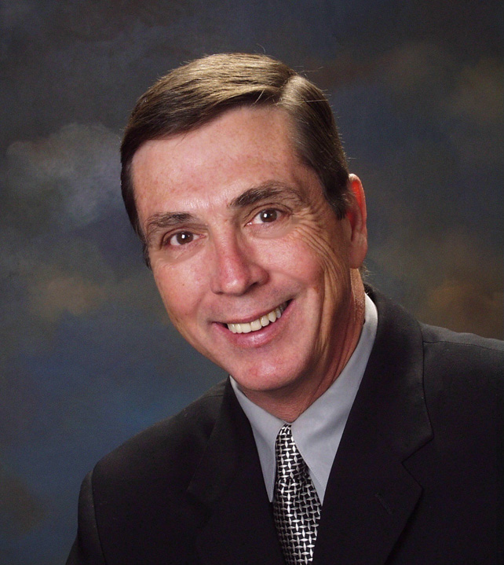
Larry Oxenham is one of America’s top asset protection experts, having helped thousands of doctors achieve financial peace of mind by teaching them how to properly structure their assets for lawsuit protection and tax reduction. He has authored and co-authored several articles and books on the subject including The Asset Protection Bible and How to Achieve Financial Peace of Mind through Asset Protection. His career has been credited with helping thousands of people save millions of dollars. He is a nationally recognized speaker who has trained thousands of professionals at hundreds of conventions, conferences and seminars across the country.

Larry Oxenham will be discussing lawsuit protection, tax reduction, and estate planning and how prosthodontists can protect 100% of their professional and personal assets from lawsuits. This continuing education course will discuss proven and effective strategies to prevent and protect against lawsuits, allowing prosthodontists the peace of mind necessary to focus on improved patient care. Tax reduction and estate planning strategies adapted to prosthodontists will also be taught.
Educational Objectives
1. Maintaining focus on improved patient care rather than lawsuit defense.
2. Structure practice for lawsuit protection and prevention.
3. Reduce liability insurance costs.
4. Minimize taxes.
We hope you will join us for this educational virtual lecture in December!
Sincerely,
Charlson Choi
Pandora Wojnarwsky
Ursula Klostermyer
Natalie Powell

**This webinar will be sponsored by the American Society for Asset Protection
This Continuing Education will be free to current ACP-VA members. There will be a non-refundable $50 fee for non-members. Larry does receive an honorarium from the American Society for Asset Protection
This continuing education activity has been planned and implemented in accordance with the standards of the ADA Continuing Education Recognition Program (ADA CERP) through joint efforts between The American College of Prosthodontists and Virginia Chapter of the American College of Prosthodontists and will be awarded 2.0 CE credits upon completion.
Participant Information

This event qualifies for 2 hours of CE from the ADA/CERP program through the American College of Prosthodontics. We sincerely hope you can join us there!
Name______________________________________________________DDS/DMD

From______________________________________________________(PRACTICE, CITY, STATE)
E-mail___________________________________________________ Phone__________________________
Please Circle One:
  - VA ACP Member . . . N/C.
  - Non-VA ACP Member . . . $50.
  - Student/resident . . . N/C
Make check payment to: Virginia ACP & send check with this form by Friday, November 29, 2021 to:
Advanced Dentistry of Richmond VA ACP Treasurer—Dr. Klostermyer
7204 Glen Forest Dr, Suite 203 Richmond, VA 23226

**If no payment is necessary, this form can be emailed to klostermyerdds@yahoo.com with email subject being ACP CE Dec 2, 2021.

