The Virginia Section of the American College of Prosthodontists would like to invite you to our upcoming webinar “Diagnostic Dilemmas-An Overview of TMD and Orofacial Pain” presented by Dr. John Kim on May 18 2022 from 6:30-8:30 pm.
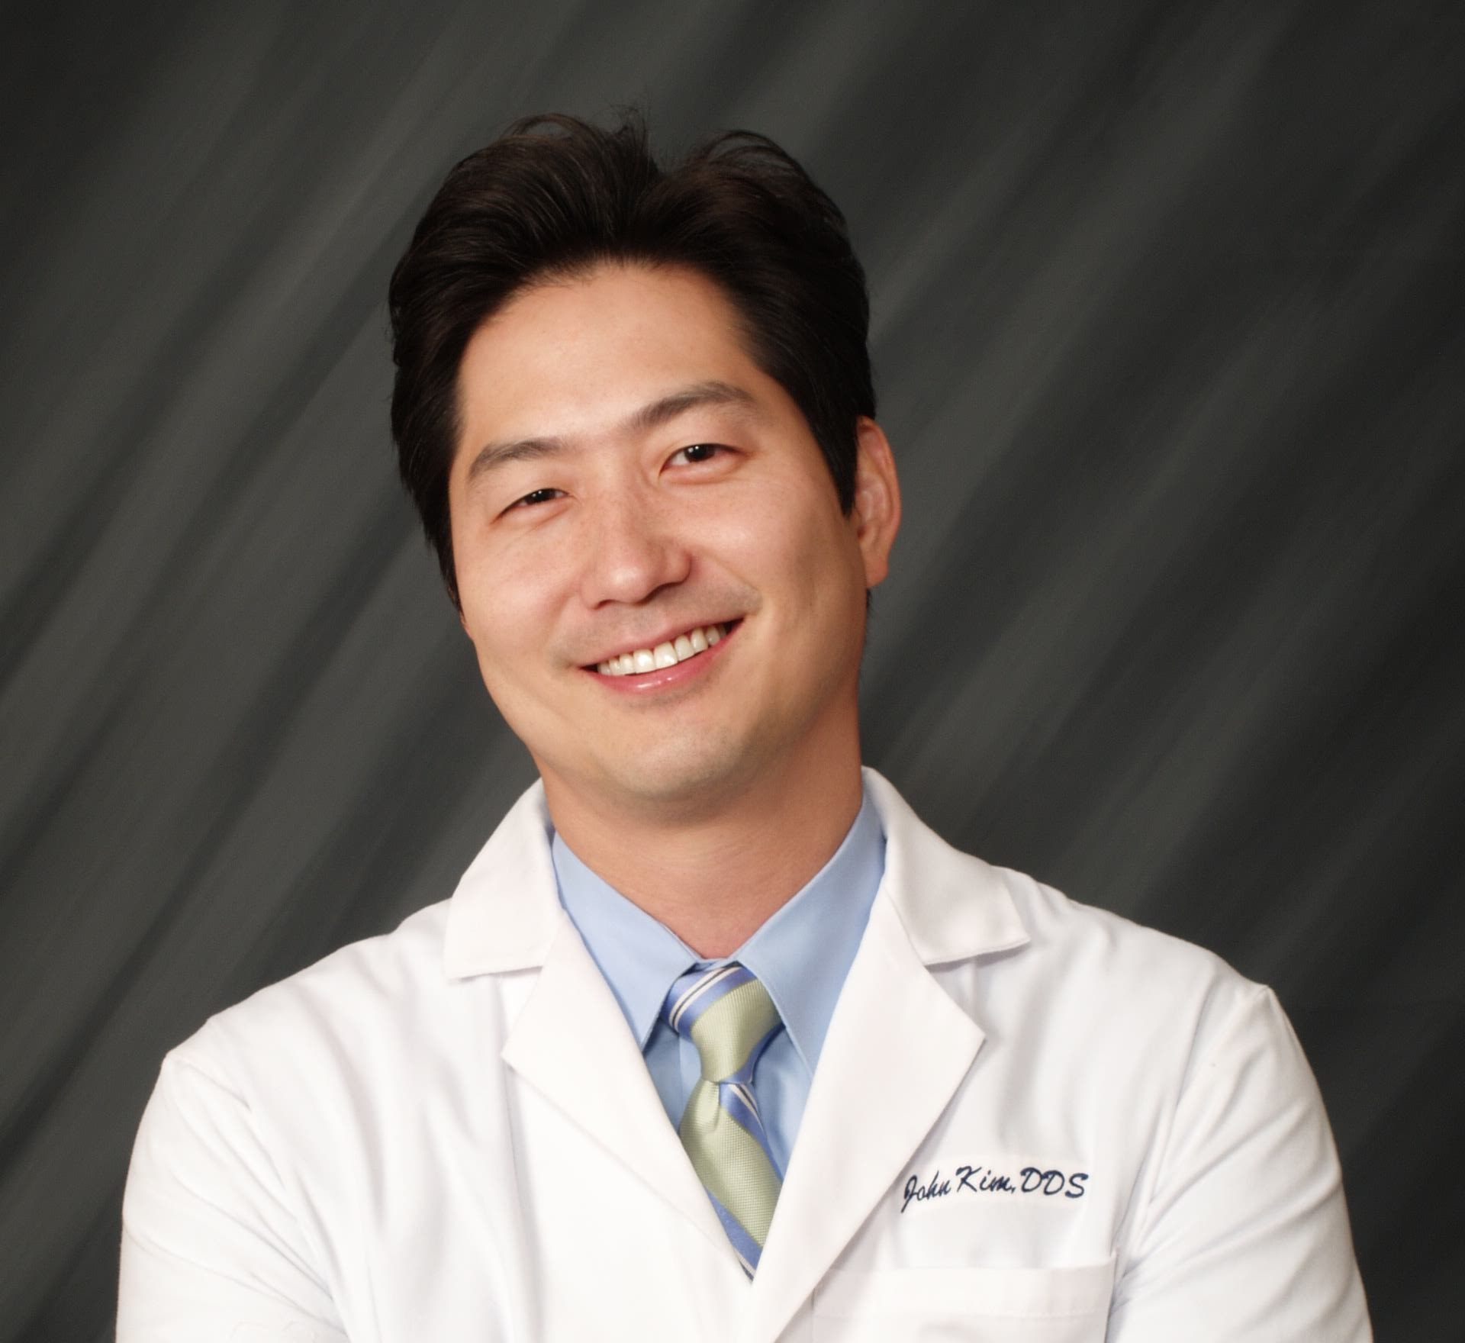
Dr. Kim received his doctorate of dental surgery from the University of Maryland School of Dental Medicine. He went on to complete a orofacial pain residency at the University of California, Los Angeles. He is a diplomate of the American Board of Orofacial Pain and maintains a private practice in Irvine, CA limited to orofacial pain and dental sleep medicine.

Dr. Kim will focus on temporomandibular disorders and the appropriate clinical diagnosis of such disorders. He will also focus on certain orofacial pain conditions to include trigeminal neuralgia and various neuropathies.
Educational Objectives
- Attain a good foundation for the diagnosis and treatment of various TMD and orofacial pain conditions

We hope you will join us for this educational virtual lecture in May!
Sincerely,
Charlson Choi
Pandora Wojnarwsky
Ursula Klostermyer
Natalie Powell

This Continuing Education will be free to current ACP-VA members. There will be a non-refundable $50 fee for non-members. There is no commerical support for this webinar and no confilicts of interest to disclose.
This continuing education activity has been planned and implemented in accordance with the standards of the ADA Continuing Education Recognition Program (ADA CERP) through joint efforts between The American College of Prosthodontists and Virginia Chapter of the American College of Prosthodontists and will be awarded 2.0 CE credits upon completion.

Participant Information

This event qualifies for 2 hours of CE from the ADA/CERP program through the American College of Prosthodontics. We sincerely hope you can join us there!
Name______________________________________________________DDS/DMD

From______________________________________________________(PRACTICE, CITY, STATE)
E-mail___________________________________________________ Phone__________________________
Please Circle One:
  - VA ACP Member . . . N/C.
  - Non-VA ACP Member . . . $50.
  - Student/resident . . . N/C
Make check payment to: Virginia ACP & send check with this form by Monday, May 16 2022 to:
Advanced Dentistry of Richmond VA ACP Treasurer—Dr. Klostermyer
7204 Glen Forest Dr, Suite 203 Richmond, VA 23226

**If no payment is necessary, this form can be emailed to klostermyerdds@yahoo.com with email subject being ACP CE May 18

