The Virginia Section of the American College of Prosthodontists would like to invite you to our upcoming webinar “Introduction to the Temporomandibular Joint: Screening and Treatment Options ” presented by Nelson Min on March 24 2022 from 6:30-8:30 pm.
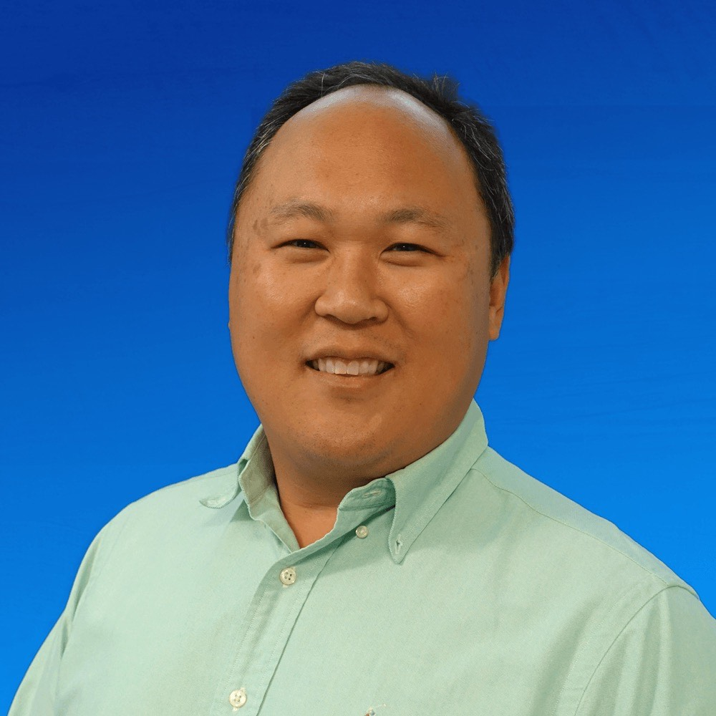
Mr. Min received his Master of Science in Physical Therapy from the University of Miami and is a board certified clinical specialist in orthopaedic physical therapy. He is an advanced functional dry needling specialist and has taught courses and presented nationwide on clinical integration of physical therapy. He has been practicing as a physical therapist since 2003 and owns Bodies in Motion Physical Therapy in Reston, VA. He has been lecturing on the treatment of the TMJ since 2016 and is currently a Specialty Course Faculty Instructor for Aspire OMT developing course content for various topics including dry needling for TMJ disorders.
Mr. Min will cover the anatomy, neurology, biomechanics, pathology and treatment for temporomandibular joint disorders at an introductory level. It will include illustrations of the muscular, bony and nervous anatomy of the jaw, face and neck. It will also include videos of live patients and cadavers to show the motions of the TMJ and the articular disc. Treatment techniques for the jaw will also be shown including the use of dry needling.
Educational Objectives
- Describe the muscular anatomy of the jaw
- Describe the motions available for the jaw
- Be able to describe a joint restriction vs a muscular restriction
- Be able to use a simple motion screen to differentiate a joint restriction or muscular restriction for the TMJ
- Be able to describe the contributors to TMJ pain and dysfunction
- Be able to describe the treatment options for TMJ dysfunction
We hope you will join us for this educational virtual lecture in March!
Sincerely,
Charlson Choi
Pandora Wojnarwsky
Ursula Klostermyer
Natalie Powell

This Continuing Education will be free to current ACP-VA members. There will be a non-refundable $50 fee for non-members. There is no commerical support for this webinar and no confilicts of interest to disclose.
This continuing education activity has been planned and implemented in accordance with the standards of the ADA Continuing Education Recognition Program (ADA CERP) through joint efforts between The American College of Prosthodontists and Virginia Chapter of the American College of Prosthodontists and will be awarded 2.0 CE credits upon completion.
Participant Information

This event qualifies for 2 hours of CE from the ADA/CERP program through the American College of Prosthodontics. We sincerely hope you can join us there!
Name______________________________________________________DDS/DMD

From______________________________________________________(PRACTICE, CITY, STATE)
E-mail___________________________________________________ Phone__________________________
Please Circle One:
  - VA ACP Member . . . N/C.
  - Non-VA ACP Member . . . $50.
  - Student/resident . . . N/C
Make check payment to: Virginia ACP & send check with this form by Monday, March 21 2022 to:
Advanced Dentistry of Richmond VA ACP Treasurer—Dr. Klostermyer
7204 Glen Forest Dr, Suite 203 Richmond, VA 23226

**If no payment is necessary, this form can be emailed to klostermyerdds@yahoo.com with email subject being ACP CE March 24

